Anthony Cunningham

STAT: 2010

12/1/2016

**Homework 12 SAS Code**

#8. **data** borneo ;

input group trees species richness ;

datalines;

1 27 22 0.81481

.

.

3 12 10 0.83333

3 12 12 1

;

**run** ;

**proc** **univariate** plot data = borneo ; * to check normality in the 3 groups;

var richness ;

by group ;

**run** ;

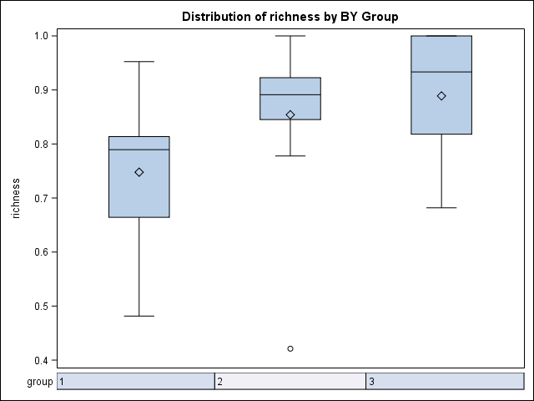

**proc** **means** data = borneo ; *to check constant std dev assumption;

class group ;

var richness ;

**run** ;

Analysis Variable : richness

N

group Obs N Mean Std Dev Minimum Maximum

ƒƒƒƒƒƒƒƒƒƒƒƒƒƒƒƒƒƒƒƒƒƒƒƒƒƒƒƒƒƒƒƒƒƒƒƒƒƒƒƒƒƒƒƒƒƒƒƒƒƒƒƒƒƒƒƒƒƒƒƒƒƒƒƒƒƒƒƒƒƒƒƒƒƒƒƒƒƒƒƒƒƒƒƒƒƒƒƒƒ

1 12 12 0.7477925 0.1201136 0.4814800 0.9523800

2 12 12 0.8541033 0.1472291 0.4210500 1.0000000

3 9 9 0.8889522 0.1134384 0.6818200 1.0000000

ƒƒƒƒƒƒƒƒƒƒƒƒƒƒƒƒƒƒƒƒƒƒƒƒƒƒƒƒƒƒƒƒƒƒƒƒƒƒƒƒƒƒƒƒƒƒƒƒƒƒƒƒƒƒƒƒƒƒƒƒƒƒƒƒƒƒƒƒƒƒƒƒƒƒƒƒƒƒƒƒƒƒƒƒƒƒƒƒƒ

#9.

**data** bromeliads;

input group $ leaves;

datalines;

C 11

.

.

NP 17

NP 14

;

**run**;

**proc** **sort** data=bromeliads;

by group;

**run**;

**proc** **univariate** plot data=bromeliads; *check normality assumption;

var leaves;

by group;

**run**;

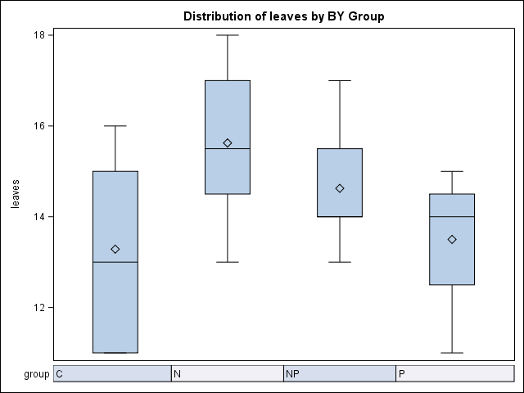

**proc** **means** data=bromeliads; *to check constant std dev assumption;

class group;

var leaves;

**run**;

Analysis Variable : leaves

N

group Obs N Mean Std Dev Minimum Maximum

ƒƒƒƒƒƒƒƒƒƒƒƒƒƒƒƒƒƒƒƒƒƒƒƒƒƒƒƒƒƒƒƒƒƒƒƒƒƒƒƒƒƒƒƒƒƒƒƒƒƒƒƒƒƒƒƒƒƒƒƒƒƒƒƒƒƒƒƒƒƒƒƒƒƒƒƒƒƒƒƒƒƒƒƒƒ

C 7 7 13.2857143 2.0586635 11.0000000 16.0000000

N 8 8 15.6250000 1.6850180 13.0000000 18.0000000

NP 8 8 14.6250000 1.3024702 13.0000000 17.0000000

P 8 8 13.5000000 1.4142136 11.0000000 15.0000000

ƒƒƒƒƒƒƒƒƒƒƒƒƒƒƒƒƒƒƒƒƒƒƒƒƒƒƒƒƒƒƒƒƒƒƒƒƒƒƒƒƒƒƒƒƒƒƒƒƒƒƒƒƒƒƒƒƒƒƒƒƒƒƒƒƒƒƒƒƒƒƒƒƒƒƒƒƒƒƒƒƒƒƒƒƒ

**proc** **anova** data = bromeliads;

class group;

model leaves=group;

**run**;

Dependent Variable: leaves

Sum of

Source DF Squares Mean Square F Value Pr > F

Model 3 27.20852535 9.06950845 3.44 0.0307

Error 27 71.17857143 2.63624339

Corrected Total 30 98.38709677